Chapter 10, Problem 19.

Obtain V_{o} in Fig. 10.68 using nodal analysis.

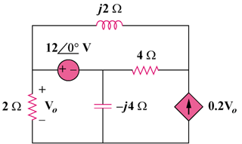

Figure 10.68
For Prob. 10.19.

